May 14, 2024

To the Editors at PLOS Computational Biology,

Please find attached our paper “Separating random and deterministic sources of computational noise in explore-exploit decisions”. In this paper we investigate the source of behavioral variability and its role in exploration.

Behavioral variability has long been thought to be useful for exploration (e.g., Sutton & Barto 1998). By behaving “randomly,” we might try something new, which can lead to new insights into a problem or new ways to obtain reward. In line with this intuition, our previous research showed that people become more random in their choices as the value of exploration is increased (Wilson et al. 2014). This finding suggests that people adapt behavioral variability in the service of exploration, but it remains unknown the source from which behavioral variability arises.

From a modeling perspective, behavioral variability is essentially the variance that cannot be explained by a model and is modeled as the level of decision noise. However, what we have called “decision noise” in previous research could actually just be missing deterministic components from the model. It is difficult to tell whether decision noise truly arises from a stochastic process, or reflects other deterministic processes missed by the model.

These two sources of behavioral variability, deterministic vs random, reflect two different strategies of exploration. In the “deterministic noise” strategy, humans could pay more attention to irrelevant stimuli in the world, allowing the distraction of random deterministic cues to increase the variability in their response. In the “random noise” strategy, variable responding could be driven more directly, by random neural firing in the brain. Previous work makes a strong case for both types of noise being relevant to behavior (Brunton et al 2013, Kao et al 2005). It is unclear which type of noise humans would use for random exploration.

Using a modified version of our explore-exploit task, in which we controlled the stimuli and let people make decisions in repeated identical scenarios, we were able to statistically distinguish random and deterministic decision noise by assessing the degree to which human participants make consistent decisions in repeated scenarios. If noise is purely deterministic, then people should make consistent choices in repeated scenarios. However, if noise is purely random, then people should make independent choices in repeated scenarios and be less consistent in their choices. By looking at the extent to which people make inconsistent choices and by fitting a novel Bayesian model in which deterministic noise and random noise can be separated, we were able to show that, while both random and deterministic noise were present in driving behavioral variability in exploration, a larger proportion of variance is explained by random noise.

Given the broad implications of our methods and findings and the growing interest in the causes of, and roles for, behavioral variability, we believe that our work will be of interest to a wide range of researchers in psychology, cognitive science and neuroscience. Our novel computational method which separates deterministic noise from random noise is applicable to studying behavioral variability in general and should be of interest to many computational scientists. As such we believe this paper is a good fit for PLOS Computational Biology.

Sincerely,



Siyu Wang, Ph.D.

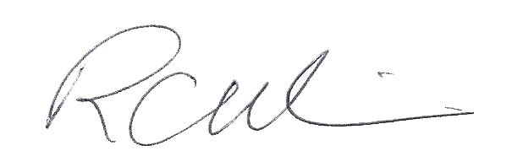  
Robert Wilson, Ph.D.

**References**

Sutton, R. S., Barto, A. G., & Bach, F. (1998). Reinforcement learning: An introduction. *MIT press*.

Wilson, R. C., Geana, A., White, J. M., Ludvig, E. A., & Cohen, J. D. (2014). Humans use directed and random exploration to solve the explore-exploit dilemma. *Journal of experimental psychology. General*, 143(6), 2074–2081.

Brunton, B. W., Botvinick, M. M., & Brody, C. D. (2013). Rats and humans can optimally accumulate evidence for decision-making. *Science*, 340(6128), 95–98.

Kao, M. H., Doupe, A. J., & Brainard, M. S. (2005). Contributions of an avian basal ganglia-forebrain circuit to real-time modulation of song. *Nature*, 433(7026), 638–643.